Frea Project

Joint Action plan - Activity 1.5

**“*Model of intervention - Toolbox*”**

Analysis step

*Essential Workation services features*

*Questionnaire*

First step: Analysis/mapping of the essential services features from each partner

In order to be able to develop new potential tourist market segments, with particular attention to the principles of inclusion and sustainability, hospitality operators need adequate information to answer to customer needs so to launch or improve their business ideas. Smart working, e.g., a lot of times carried out in a holiday location (workation), represents a great potential for relaunching the economy of regions and inland areas and can help to deseasonalize traditional tourism.

Hence, by considering the results of the workshop and targeted trainings implemented in the first period of the project, a **cross-border mapping of the essential services features** **required by the tourism operators**, specifically oriented to workation, will be arranged to set out the categories of entrepreneurs which will be interested in developing new potential tourist market segments. In this way, the possible gaps with respect to the operators’ and customers' needs will be highlighted in a cross-border approach. The first activity is related to the preparation of a specific questionnaire.

.1 – Services’ features Questionnaire

The preparation of the questionnaire takes into preliminary account the activities conducted during the 2 workshops (Puglia and Montenegro) and the 3 training activities (Puglia, Albania, Molise). The underlying methodology involves administering the questionnaire to a selected basket of operators, based on a sampling procedure that takes into account the geographical location in the area.

In particular, starting from a complete list of the tourism operators (Resorts, Residential Hotels, 2-3 Stars Hotels, Farmhouse, B&Bs) operating over the involved Partners’ territories (a regional/national organization of tourism activities can provide the list), a stratified sample will be constructed.

The stratification will be carried out in terms of type/category of tourism operator as well as in terms of specific characteristic (socio-economic and/or environmental) of the sub-areas where the tourism operator is located over the Partners’ territories. Each Partner will set up the classes to be considered for the stratification (for example, with reference to the geographical profile, midland/coastal/rural/mountain area).

Therefore, giving the total number of the tourism operators listed as above specified (population size), and by fixing an estimation error ranging from 7 to 9 per cent, the following sample sizes can be considered, for different levels of the population size:

|  |  |  |
| --- | --- | --- |
|  | Sample size | |
| Population size | Error equal to 7% | Error equal to 9% |
| 80 | 57 | 48 |
| 100 | 66 | 54 |
| 150 | 85 | 66 |
| 200 | 99 | 75 |

Evidently, after fixing the target sample size, the sample distribution is proportionally split among the different classes according with the percentage of the same classes.

Each partner will be able to optimize the composition of the sample taking into account its own specificities. The objective is to collect a minimum number of questionnaires useful for explaining the actual characteristics of the services requested on the topic of Workation.

**2. Questionnaire specific objectives and results**

The questionnaire, developed as part of the activities of the FReA Project (Interreg IPA South-Adriatic Program 2021-2027), represented a useful tool for analyzing the characteristics of the services provided by tourism operators with reference to the workation segment.

In fact, through the administration of the questionnaire, the aim was to collect information on the forms of workation introduced by the selected companies, as well as to measure, on a preliminary basis, their tourism innovation needs.

The objective was to collect a basket of information on the tourist situation, which constitutes the basis for preparing initiatives aimed at encouraging the diffusion of new paradigms, but also concrete services for tourists.

Therefore, the questionnaire aimed to highlight the current state of diffusion of workation, its potential and the concrete difficulties in the processes of organizing and providing this form of tourism.

The questionnaire was divided into 6 sections:

• Section 1: General information,

• Section 2: Worktation offers,

• Section 3: Customer Experience and Feedback,

• Section 4: Promotion and marketing,

• Section 5: Future of workation,

• Section 6: Conclusions,

The purpose of the questionnaire was purely cognitive. The data provided, processed anonymously, will be used in aggregate form for statistical purposes only.

The companies that responded to the questionnaire will be involved in a subsequent in-depth process, through the organization of testing phases and B2B meetings.

**QUESTIONNAIRE RESULTS**

The total number of questionnaires collected is 21. Below are the main results that emerged and elaborated on the basis of the answers provided by the companies interviewed.

In Section 1: General information of the questionnaire (consisting of 6 questions), companies were asked to indicate, in addition to general data (such as name/company name, year of incorporation, registered and operational headquarters address, any membership in groups of companies etc.), the legal form of the company, the economic sector in which it operates and the reference market.

This chart shows the distribution of responses for the legal form of companies among 21 participants. Here's a breakdown:

**Sole Proprietorship (57.1%)**: A majority of respondents (12 out of 21) indicated that their companies are sole proprietorships. This indicates a strong preference for individual ownership and management among the sample.

**Limited Liability Company (28.6%)**: The second-largest category is Limited Liability Companies (6 out of 21), showing a significant number of businesses prefer the legal protection and structural benefits that LLCs offer.

**Simple Company (14.3%)**: A smaller portion (3 out of 21) selected "Simple Company," which suggests fewer companies are organized under this less common or simplified form.

Other legal forms, such as partnerships, joint-stock companies, or cooperative societies, are not represented in the responses. This could imply they are either uncommon in the sample group or were not selected.

The dominance of sole proprietorships suggests that the majority of businesses are likely small-scale and owner-operated. These businesses may prefer simpler structures to minimize administrative costs and regulatory burdens.

The second-largest category indicates that a significant proportion of businesses are structured to separate personal and business liabilities. LLCs are often preferred by companies seeking more professional credibility and growth opportunities.

This smaller proportion indicates a niche category of businesses that opt for a "lighter" structure, likely offering flexibility while still formalizing their operations. It’s possible these businesses are in specific industries or are newer ventures testing their markets.

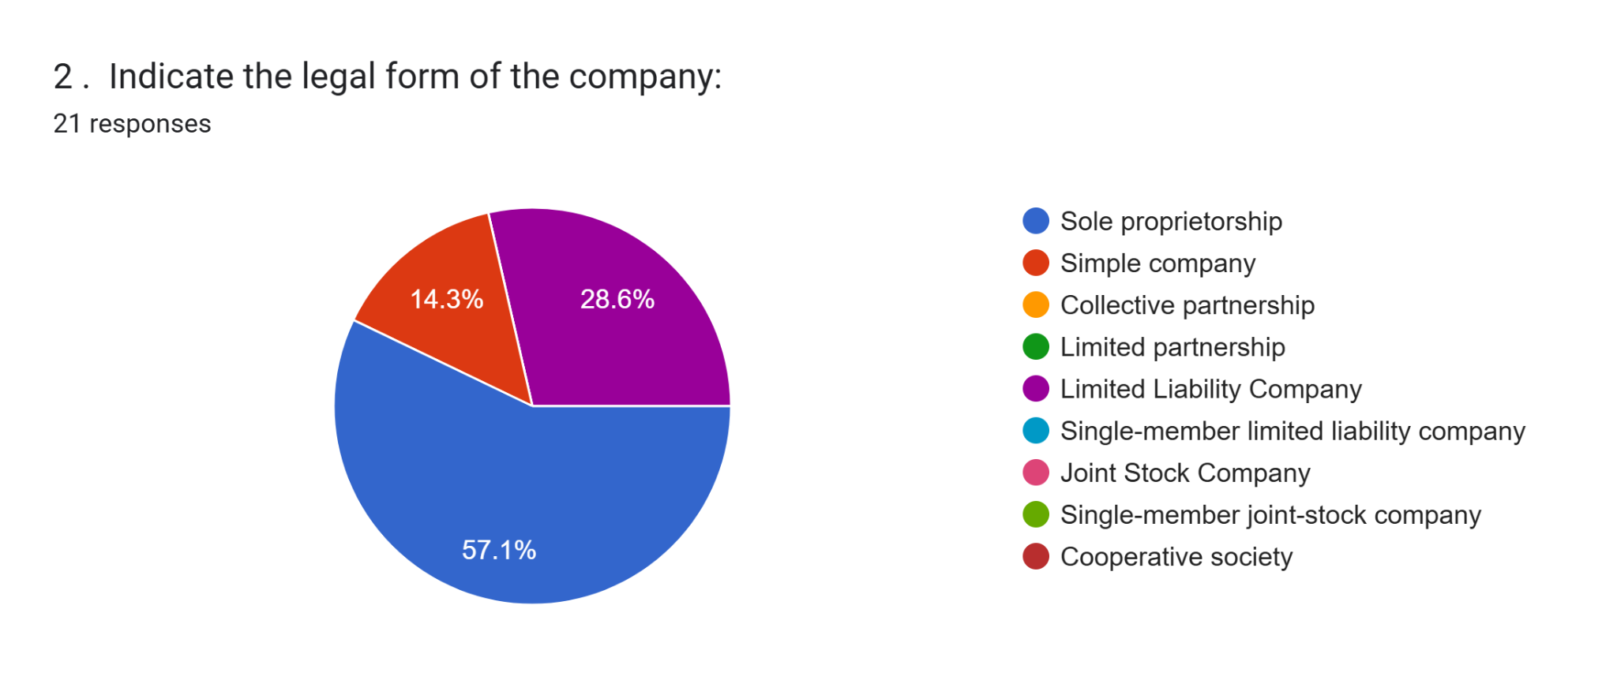

This chart provides an overview of the main reference markets for the surveyed businesses. The largest share, **42.9%,** operates at the regional level, indicating that most businesses focus on serving a market within their immediate geographical area, likely leveraging regional networks and infrastructure. This suggests the regional economy plays a vital role in their operations, although it may also highlight a dependency on localized demand.

A smaller but still significant group, **28.6%,** identifies the national market (Montenegro) as their primary focus. These businesses may be slightly larger or more diverse, targeting customers across the country and suggesting a broader operational scope. However, this also implies they might face challenges related to logistics, regulatory differences, or competition across different parts of the country.

Interestingly, **23.8%** of the respondents report that their primary market is abroad. This highlights a group of businesses that are likely export-oriented or internationally competitive. Such businesses are critical for driving economic growth and integration into the global market, although they may face unique challenges such as trade barriers, currency fluctuations, or meeting international standards.

Finally, only **4.8%** of businesses concentrate their activities within their local province. This low representation could indicate that purely local operations are either rare or unsustainable for many types of businesses, possibly due to limited market size or the need for diversification.

Overall, the data suggests a strong emphasis on regional and national markets, with a smaller but noteworthy presence in international trade. Supporting businesses in scaling from local to regional or international markets could be a strategic priority, as could fostering innovation and competitiveness for export-oriented firms.

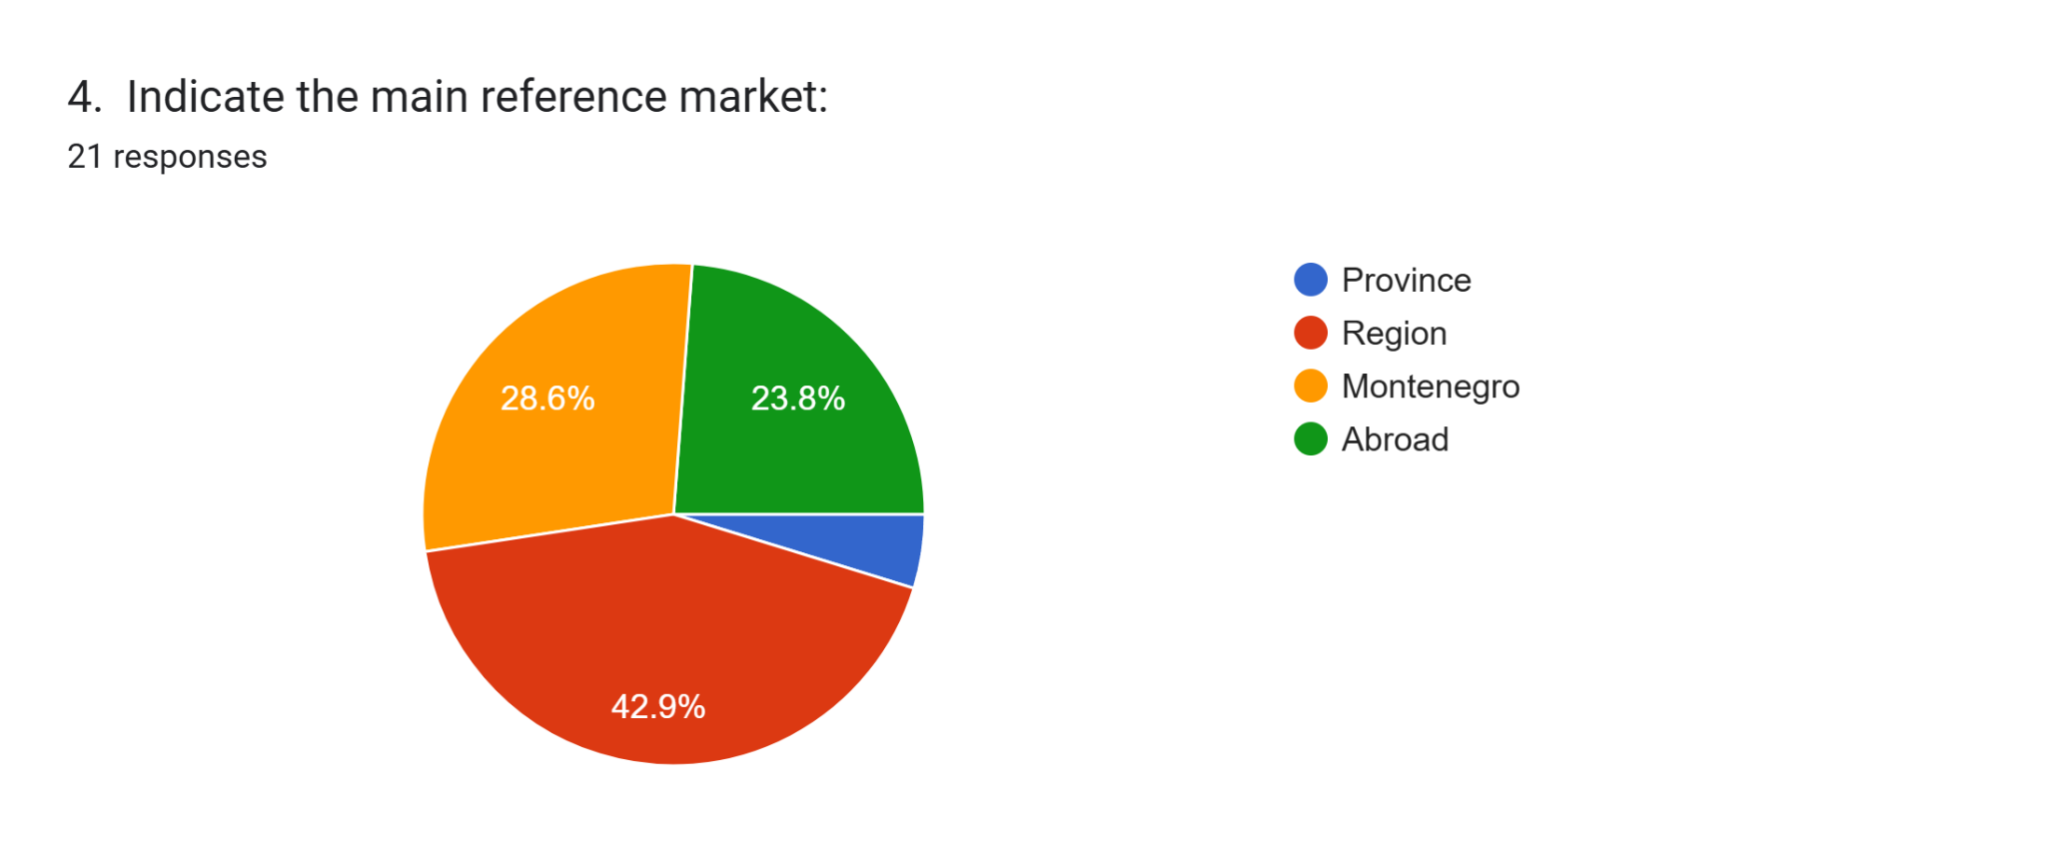

This graph provides an overview of the services included in workation packages based on the responses of 21 participants. The most commonly included service is high-speed internet, which was selected by **71.4%** of respondents, making it an essential offering for remote workers. Long-term stay packages are also popular, chosen by **61.9%** of participants, indicating their appeal to those seeking extended stays.

Coworking spaces were included in **47.6%** of responses, reflecting their importance for individuals who require a dedicated workspace. Similarly, excursions and tourist activities, along with catering and room service, were each selected by **42.9%** of participants, showing their significance in combining work and leisure. Meeting rooms were mentioned by 38.1% of respondents, highlighting their relevance for group or client interactions.

On the other hand, services like leisure and wellness activities (19%), video conferencing equipment (23.8%), and printing services (23.8%) were less commonly included. Secretarial services were not selected by any participants, suggesting they are the least relevant offering in this context.

Overall, the results emphasize that practical services like internet access, coworking spaces, and accommodation are the top priorities for individuals opting for workation packages. In contrast, leisure-focused or niche professional services appear to be less significant, providing a clear direction for service providers to align their offerings with the needs of their target audience.

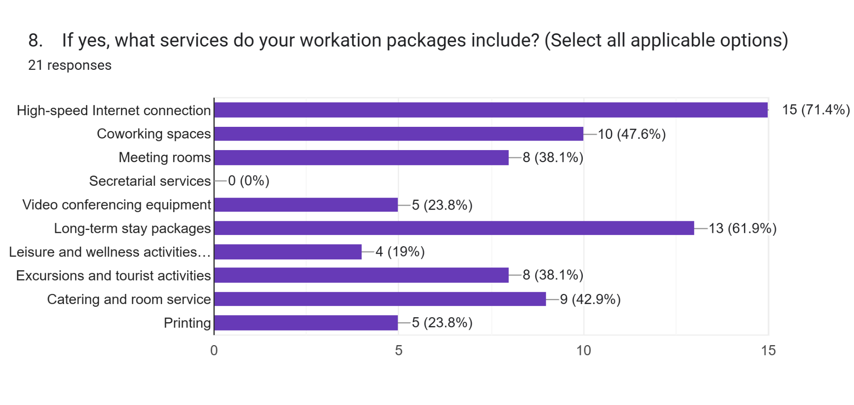

The chart presents data on the average duration of workation stays provided by facilities, based on 33 responses. The majority of providers (60.6%) offer stays that last less than a week, making this the most common option. Approximately 30.3% of providers accommodate stays of 1 to 2 weeks, which is the second most frequent duration. Only a small percentage of providers offer longer stays, with very few allowing durations of 2 to 4 weeks or more than a month. This suggests that short-term workations are the most prevalent offering among these facilities.

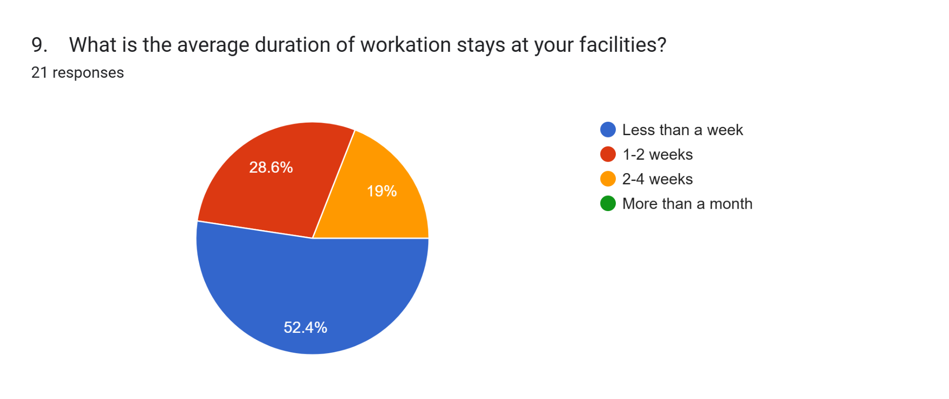

The chart provides insights into the main target audiences for workation packages based on 21 responses. Freelancers are the most commonly targeted group, with 61.9% of respondents identifying them as their primary audience. Remote workers and digital nomads are equally prioritized, with 47.6% of respondents indicating these groups as key audiences. A smaller proportion, 23.8%, focuses on companies that offer workation options to their employees, highlighting some interest in corporate partnerships. Meanwhile, only 4.8% of respondents stated that they do not have a specific target audience. Overall, the data suggests that workation providers primarily cater to individual professionals, such as freelancers and remote workers, with some attention given to corporate opportunities.

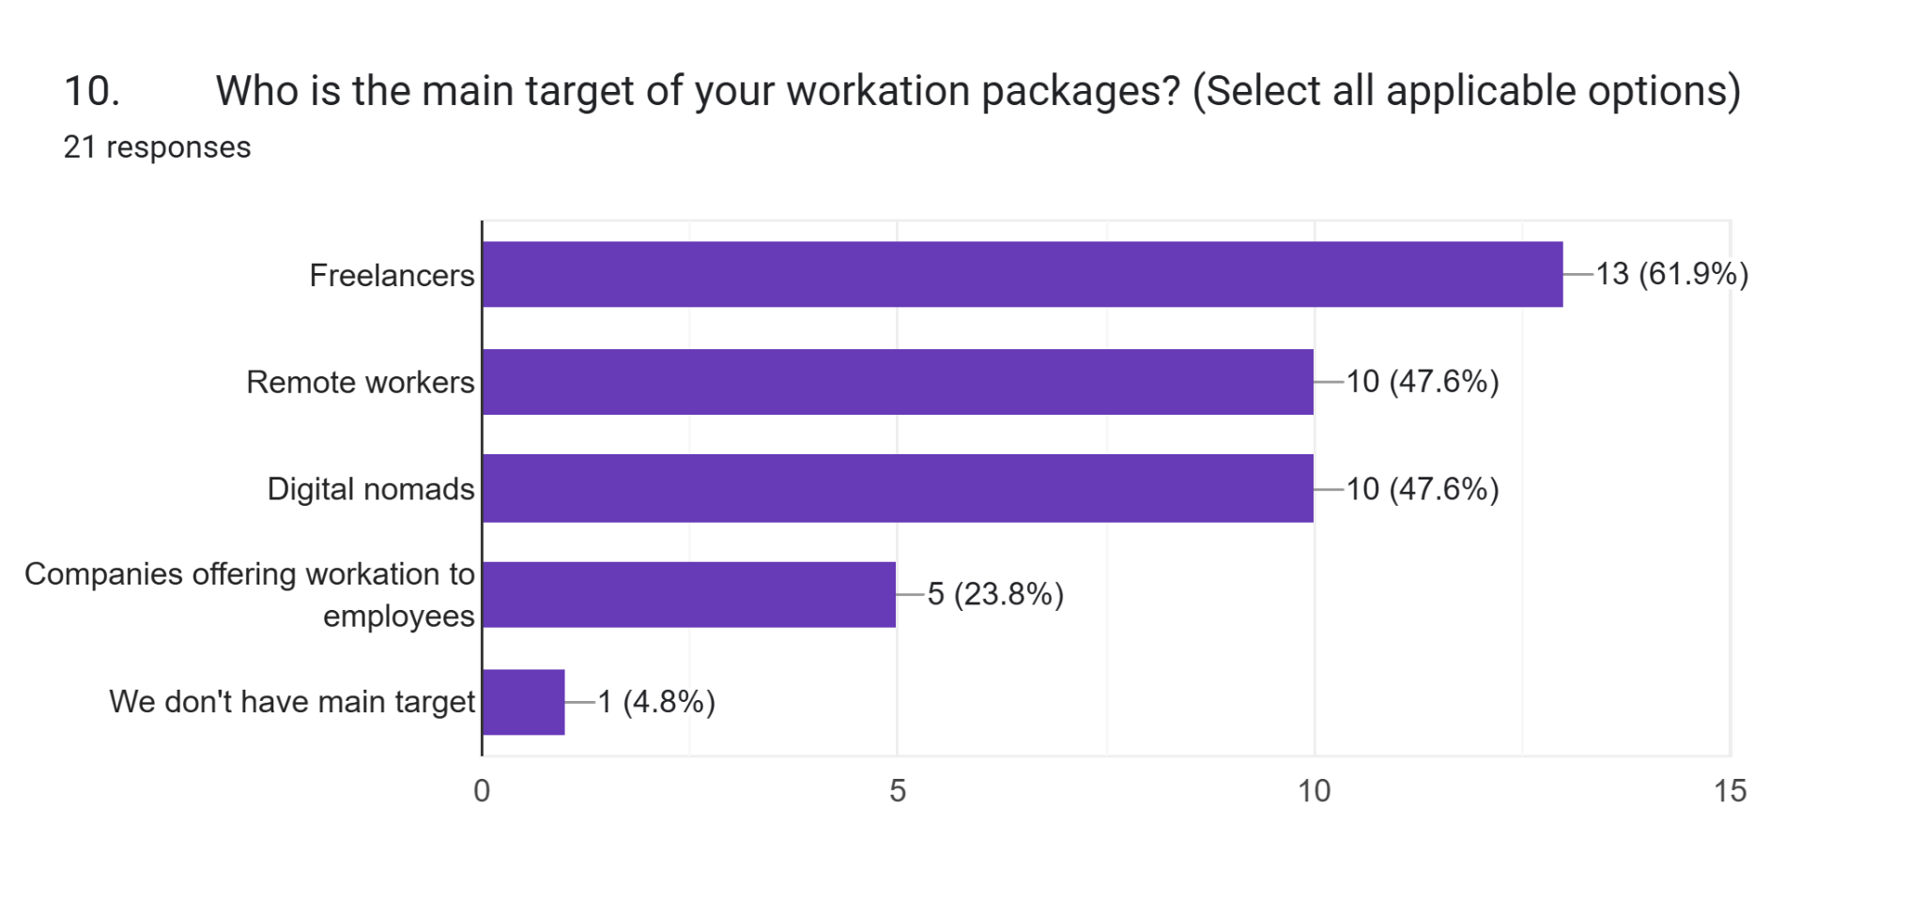

The chart provides insights into the main target audiences for workation packages based on 21 responses. Freelancers are the most commonly targeted group, with **61.9%** of respondents identifying them as their primary audience. Remote workers and digital nomads are equally prioritized, with **47.6%** of respondents indicating these groups as key audiences. A smaller proportion, **23.8%**, focuses on companies that offer workation options to their employees, highlighting some interest in corporate partnerships. Meanwhile, only **4.8%** of respondents stated that they do not have a specific target audience. Overall, the data suggests that workation providers primarily cater to individual professionals, such as freelancers and remote workers, with some attention given to corporate opportunities.

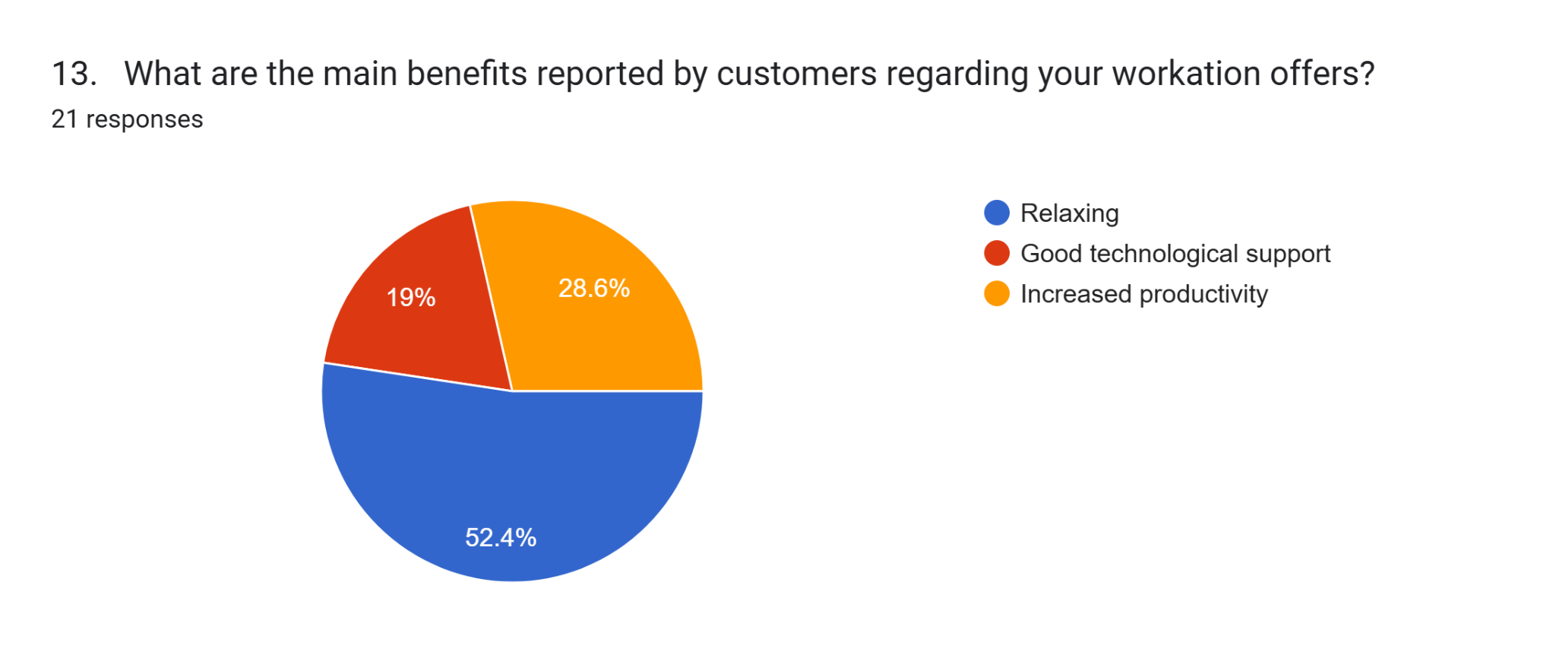

The chart highlights the main challenges in providing workation services in rural areas, based on 21 responses. The most commonly cited issue, reported by **47.6%** of respondents, is the lack of knowledge about the potential benefits of workation services. This suggests a significant gap in awareness or promotion. Another major concern, mentioned by **38.1%,** is the insufficient training of tourism employees, which could hinder the quality of service.

A third of respondents (33.3%) identified that accommodations are not adequately prepared to support workation needs, indicating infrastructural or logistical shortcomings. Issues such as no Wi-Fi connection, depopulation, and other unspecified problems were each mentioned by **14.3%** of respondents. Additionally, the low appeal of inner tourist destinations was cited by **9.5%** of respondents. Notably, cultural approach was not identified as a challenge by any respondent.

Overall, the findings emphasize the need for better awareness, staff training, and improvements in infrastructure to successfully implement workation services in rural settings.

Forms response chart. Question title: 14. In your opinion, which are the main problems to offer workation services in rural areas?
. Number of responses: 21 responses.

The chart illustrates the results of a survey on essential tools for workation tourism operators, based on responses from 21 participants. The most valued tool, selected by 52.4% of respondents (11 people), is "communication tips & tricks." "Financial advice documents" and "synthesis on funding opportunities" are equally important, with each being chosen by 38.1% of respondents (8 people). Following closely, "enterprise creation quick referral guide" was selected by 33.3% (7 people). "Project management templates" were deemed essential by 23.8% of respondents (5 people), while "handbook for actors" was the least favored, chosen by only 4.8% of respondents (1 person). The results highlight a strong preference for communication-focused resources, while tools like actor handbooks are considered less relevant.

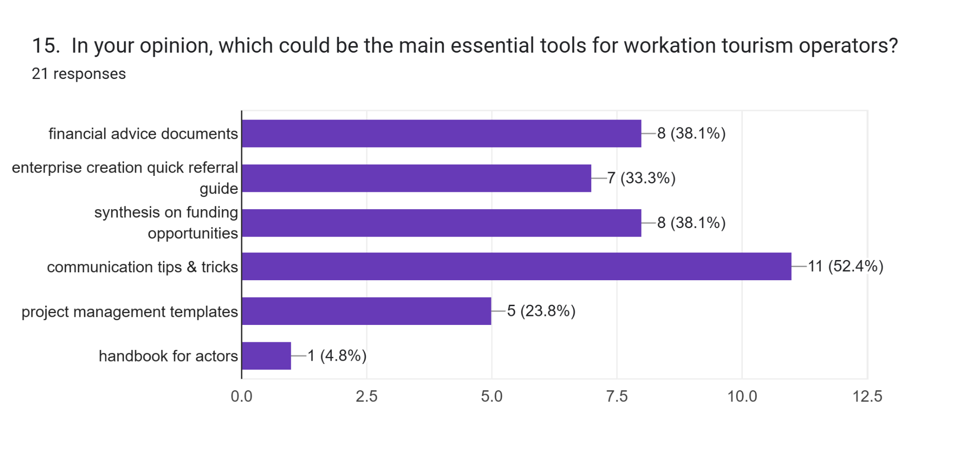

The chart presents the preferred channels used by workation tourism operators to promote their offers, based on 21 responses. Social media stands out as the dominant platform, used by 95.2% of respondents (20 people). Online advertising, such as Google Ads and Facebook Ads, is the second most popular option, utilized by 61.9% of respondents (13 people). The company website is another significant channel, chosen by 42.9% (9 people). In contrast, collaborations with influencers and participation in industry fairs and events are less frequently used, with each being selected by 9.5% of respondents (2 people). Newsletters were not chosen by any of the participants. These results indicate a strong reliance on digital channels, particularly social media, for promotional efforts.

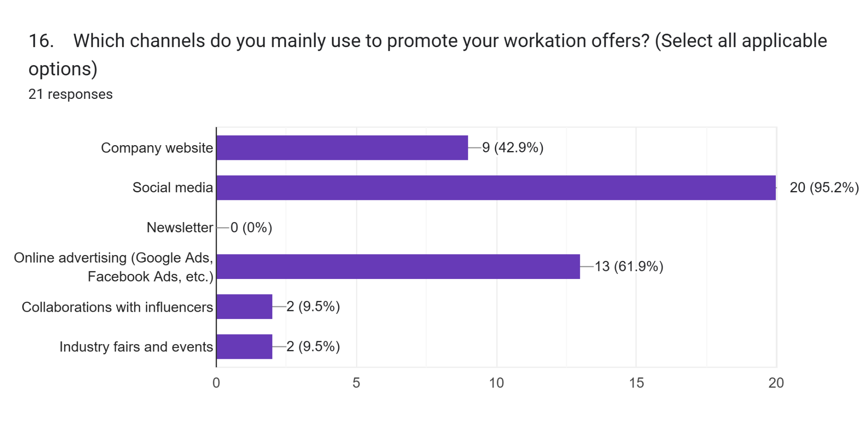

The pie chart illustrates opinions on the future demand for workation over the next 2–3 years, based on 21 responses. A significant majority, 71.4% of respondents, believe that the demand will increase. Meanwhile, 23.8% predict that the demand will remain stable, and only a small minority, 4.8%, expect it to decrease. This data suggests a general optimism about the growth of workation opportunities in the near future.

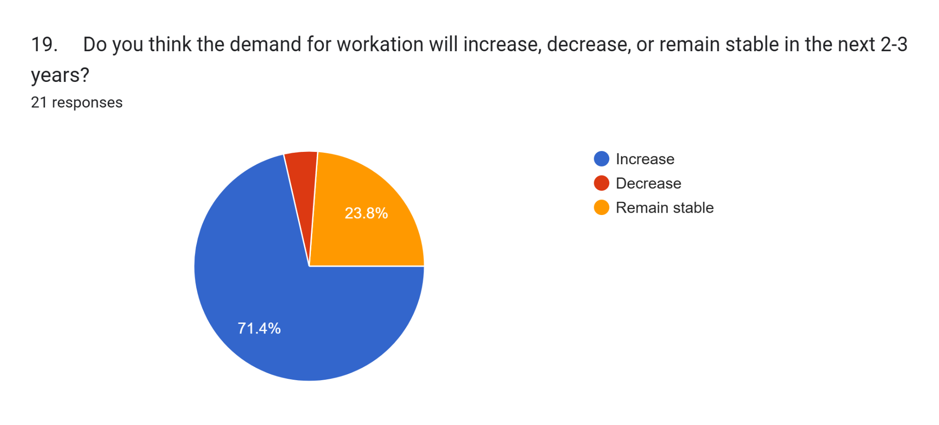Interesting are the future plans that companies intend to implement to improve or expand their workation offers, which can be summarized as follows:

* Eco certification, sauna
* Equipment improvement and promotion
* To increase advertisements, especially in developed countries.
* To increase asvertisments, especially in developed countries
* Presented by tourist organization
* Our future plans for improving and expanding workation offers at our camp and apartments on Durmitor include increasing accommodation capacity, introducing additional facilities for work and relaxation such as outdoor co-working spaces, high-speed internet, and organizing specialized workshops and team-building activities. Our goal is to provide the ideal conditions for balancing work and leisure, allowing guests to work productively while enjoying the natural beauty of Durmitor.
* To invest more in providing better conditions
* We do not have specific plans regarding this
* Technical support and more space

Furthermore, companies were asked to provide an evaluation (with a score from 1 to 5, where 1 indicates that one totally disagrees and 5 that one totally agrees) with respect to the statements indicated below relating to the characteristics of the workation:

|  |  |  |  |  |  |
| --- | --- | --- | --- | --- | --- |
| **Workation Key characteristics** | **Evaluation score (from 1 to 5)** | | | | |
| **1** | **2** | **3** | **4** | **5** |
| 1. Workation, as a new form of tourism, is a work model for the future | 0  0% | 1  0% | 0  0% | 13  **61,9%** | 8  38,1% |
| 2. Workation allows for a longer holiday stay | 0  0% | 0  0% | 2  9,5% | 15  **71,4%** | 4  19% |
| 3. Workation leads to an increase in demand for local products/services | 0  0% | 0  0% | 2  9,5% | 15  **71,4%** | 4  19% |
| 4. Workation allows an increase in the quality of life | 0  0% | 1  2,9% | 2  9,5% | 15  **71,4%** | 4  19% |
| 5. Workation ensures an increase in productivity | 0  0% | 0  0% | 2  9,5% | 14  **66,7%** | 5  23,8% |
| 6. Workation guarantees greater development of the tourism product | 0  0% | 0  0% | 2  9,5% | 11  **52,4%** | 8  38,1% |
| 7. What are the main reasons for requesting Workation? To escape the routine | 0  0% | 0  0% | 3  14,3% | 8  38,1% | 10  **47,6%** |
| 8. What are the main reasons for requesting Workation? Meet new friends | 0  0% | 0  0% | 12  **57,1%** | 7  33,3% | 2  9,5% |
| 9. What are the main reasons for requesting Workation? To prevent or address burnout (excessive fatigue) | 0  0% | 0  0% | 6  28,6% | 13  **61,9%** | 2  9,5% |
| 10. What are the main reasons for requesting Workation?  To avoid feeling stuck in one place | 0  0% | 0  0% | 3  14,3% | 14  **66,7%** | 4  19% |
| 11. What are the main reasons for requesting Workation?  Mental recharge | 0  0% | 0  0% | 1  4,8% | 14  **66,7%** | 6  28,6% |

Finally, in Section 6: Conclusions of the questionnaire (consisting of 1 question), companies were given the opportunity to add a further comment regarding their work experience or offer. The comments are summarized below:

* The idea of combining work and travel is fantastic. Looking forward to more customized packages that cater to both productivity and relaxation.
* It would be great to see more diverse activities and flexible pricing options included in workation packages.
* I think these packages are a great idea, and I look forward to seeing how they grow to meet the needs of remote workers.
* Offering more hybrid options that combine co-working spaces with leisure activities would make these packages even more appealing."