Frea Project

Joint Action plan - Activity 1.5

**“*Model of intervention - Toolbox*”**

**Deliverable 1.5.3**

*Reports for the ApMM in Ulcinj, Montenegro*

Synthesis of documents and attachments

Index

A. Introduction: the JAP rationale 3

B. The JAP four steps 4

1. First step: Analysis/mapping of the essential services features from each partner 6

1.1 – Services’ features Questionnaire 6

2. Model step 8

3. Testing step 10

4. Follow up step 10

# Introduction: the JAP rationale

The definition of a Joint Action Plan has as its fundamental objective of mapping and verifying the essential characteristics (features) of the services useful for the organization of the tourism activities connected to the topic of workation.

The understanding of the needs of operators and related market trends allows to rationalize information on a front-line issue, considering that in many cases it is not clear how to optimize the efforts of different actors.

The parallel design of a “toolbox”, understood as an overall system of information, tools and potential support services, allows to better organize economic activity and personalize the offer for tourists.

The activities envisaged by the project also include a testing phase of the proposed package and the formalisation, through the signing of a memorandum of understanding, of the specific desire to support the development of the specific Workation tourism niche.

# The JAP four steps

1. Analysis Step

A cross-border mapping of the essential services features required by the tourism operators will be arranged, also considering the results of the workshop and targeted trainings implemented in the 1st period of the project.

1. Model Step

A standard model based on financial advice documents, enterprise creation quick referral guide, synthesis on funding opportunities, communication tips&tricks, project management templates, handbook for actors will be developed. The set of tools will form a complete “toolbox”.

1. Testing Step

A concept test for the model of services is implemented - based on the toolbox - and personalized on the specific socio-economic features of all the partners’ territories.

Practical tests are made on those hospitality operators able to deepen the characteristics of their business environment and access to a set of highly operational services.

1. Follow-up Step

A memorandum of understanding is defined and signed by each partner which has the objective to set up their willingness to follow up on the proposed model of services. The agreement specifies all the features of the model.

* Deliverables

4 reports for the ApMM are provided by each of the following partners:

* Molise Region (D.1.5.1)
* Albania (D.1.5.2)
* Montenegro (D.1.5.3)
* A summary of the contributions provided by the partners to develop the ApMM for the model of services, will be prepared by Molise in collaboration with Unisalento (D.1.5.4)

The following table summarizes the JAP phases throughout the period of implementation of project activities.

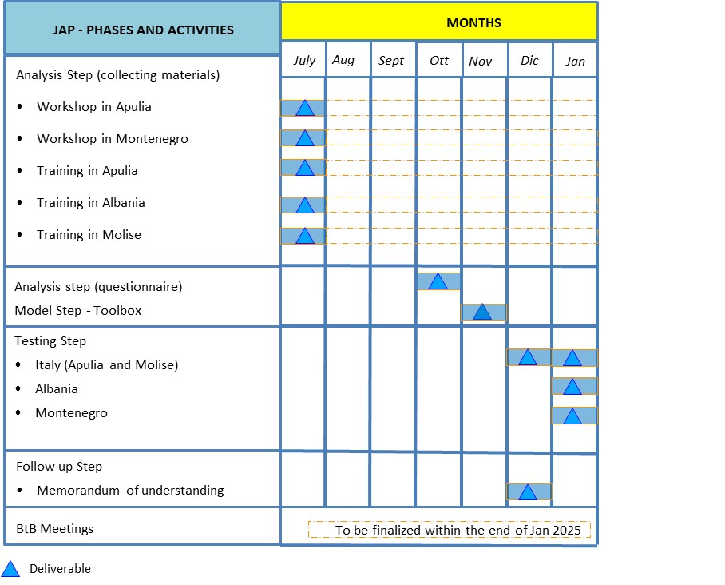

# First step: Analysis/mapping of the essential services features from each partner

In order to be able to develop new potential tourist market segments, with particular attention to the principles of inclusion and sustainability, hospitality operators need adequate information to answer to customer needs so to launch or improve their business ideas. Smart working, e.g., a lot of times carried out in a holiday location (workation), represents a great potential for relaunching the economy of regions and inland areas and can help to deseasonalize traditional tourism.

Hence, by considering the results of the workshop and targeted trainings implemented in the first period of the project, a **cross-border mapping of the essential services features** **required by the tourism operators** has been arranged to set out the categories of entrepreneurs which will be interested in developing new potential tourist market segments. In this way, the possible gaps with respect to the operators’ and customers' needs have been highlighted in a cross-border approach. The first activity is related to the preparation of a specific questionnaire.

## 1.1 – Services’ features Questionnaire

The preparation of the questionnaire takes into preliminary account the activities conducted during the 2 workshops (Puglia and Montenegro) and the 3 training activities (Puglia, Albania, Molise). The underlying methodology involves administering the questionnaire to a selected basket of operators, based on a sampling procedure that takes into account the geographical location in the area.

In particular, starting from a complete list of the tourism operators (Resorts, Residential Hotels, 2-3 Stars Hotels, Farmhouse, B&Bs) operating over the involved Partners’ territories (a regional/national organization of tourism activities can provide the list), a stratified sample has been constructed.

The stratification has been carried out in terms of type/category of tourism operator as well as in terms of specific characteristic (socio-economic and/or environmental) of the sub-areas where the tourism operator is located over the Partners’ territories. Each Partner set up the classes to be considered for the stratification (for example, with reference to the geographical profile, midland/coastal/rural/mountain area).

Therefore, giving the total number of the tourism operators listed as above specified (population size), and by fixing an estimation error ranging from 7 to 9 per cent, the following sample sizes have been considered, for different levels of the population size:

|  |  |  |
| --- | --- | --- |
|  | Sample size | |
| Population size | Error equal to 7% | Error equal to 9% |
| 80 | 57 | 48 |
| 100 | 66 | 54 |
| 150 | 85 | 66 |
| 200 | 99 | 75 |

Evidently, after fixing the target sample size, the sample distribution is proportionally split among the different classes according with the percentage of the same classes. Each partner has been able to optimize the composition of the sample taking into account its own specificities. The objective has been to collect a minimum number of questionnaires useful for explaining the actual characteristics of the services requested on the topic of Workation.

For the Montenegro region, the population of companies considered for the questionnaire administration activity was 300 units. The email addresses of the recipients were sourced from a dedicated database available to the company, which undergoes regular updates and verification checks.

The selected operators were identified based on the Central Touristic Registry under the Ministry for Economic Development, which categorizes economic activities performed by companies (hotels, B&Bs, resorts, agritourism activities, etc.). This classification ensured that only active operators in the reference sector were included. All selected companies were confirmed to have at least one operational headquarters located in Montenegro.

The total number of questionnaires collected is 21. Below are the main results that emerged and were analyzed based on the responses provided by the companies interviewed.

Attachment: *Services’ features Questionnaire.doc*

Attachment: *Questionnaire results*

# Model step

A standard model based on financial advice documents, enterprise creation quick referral guide, synthesis on funding opportunities, communication tips&tricks, project management templates, handbook for actors has been developed. The set of tools forms a complete “toolbox”.

The toolbox is composed by 4 guides (Enterprise creation, Finance & Funding Opportunities, Communication Tips & Tricks, Project management & Handbook) and related attachments.

Regarding the Montenegro region, emphasis has been placed on funding opportunities and enterprise creation processes in accordance with Montenegrin law.

In detail the “FRea_JAP_2_Model (Toolbox)” folder contains the following sub-folders:

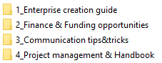



* Enterprise creation
* FRea_JAP_2_Toolbox_ENTERPRISE CREATION GUIDE
* FRea_JAP_2_Toolbox_ENTERPRISE CREATION GUIDE.ppt



* Finance & Funding Opportunities
* FRea_JAP_2_Toolbox_SYNTHESIS ON FUNDING OPPORTUNITIES
* Communication Tips & Tricks
* FRea_JAP_2_Toolbox_Communication Tips & Tricks
* FRea_Communication Activities_tool.xls



* Project management & Handbook
* FRea_JAP_2_Toolbox_Project mgmt & Handbook

# Testing step

Based on the toolbox available from the previous step, a concept test for the model of services has been implemented. Practical tests have been made on those hospitality operators able to deepen the characteristics of its business environment and access to a set of highly operational services, such as business creation, developed mainly through digital marketing solutions (internet pages, online folder sharing, thematic database, single meetings, networking assistance).

The aim has been to prevent aspiring entrepreneurs from neglecting problematic aspects connected to the activity they intend to carry out. Importance has been given to the analysis of the capacity to access to financial aids and technical-economic sustainability of each initiative, through specific items or indicators.

The concept test, based on an excel tool (attached), has been personalized on the specific socio-economic features and services of all the partners’ territories, while the concrete possibility of implement a cross-border network (“Networking with other IPA countries” item) has been analyzed.

**

Attachment: *FRea_JAP_3_Testing.doc*

For Montenegro, 9 concept tests have been collected, 6 positive results and 3 negative.

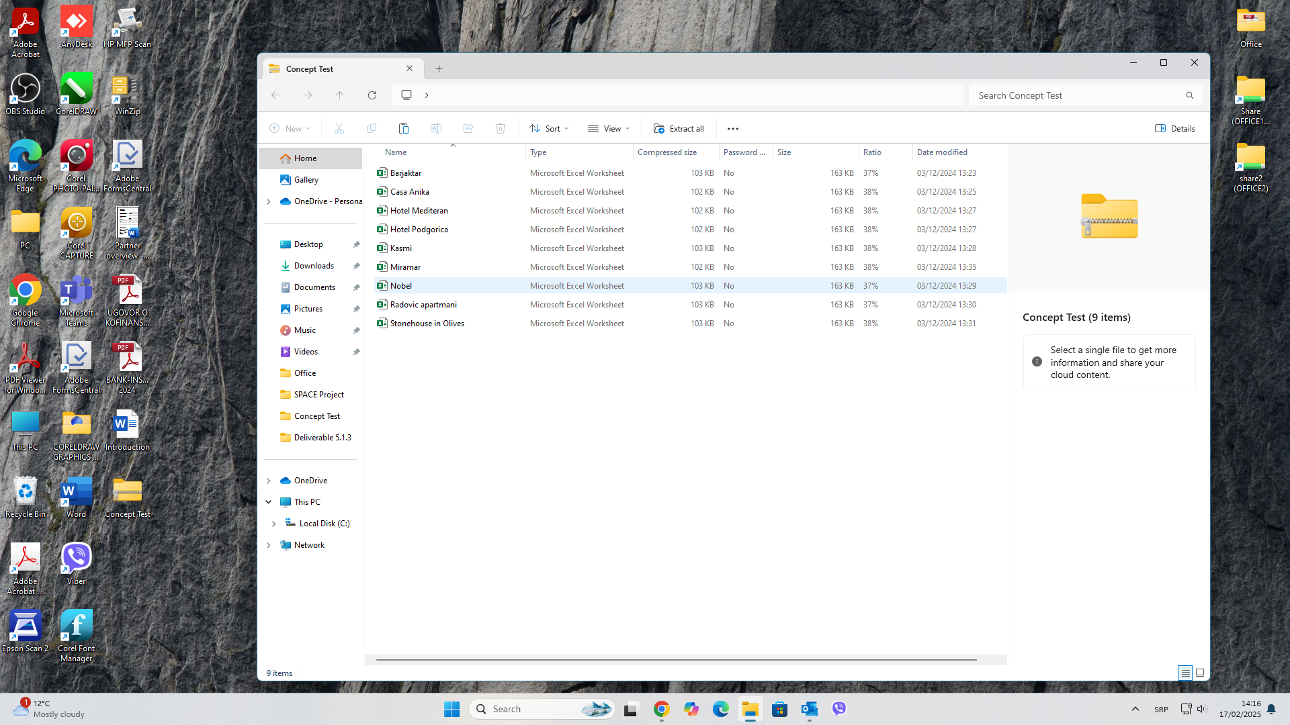

# Follow up step

A memorandum of understanding has been defined and signed by each partner which has the objective to set up their willingness to follow up on the proposed model of services. The agreement specified the main features of the model. An additional MoUs has been signed by tourism operators.

**

Attachment: *FRea_JAP_4_Follow up (MoUs)*

**Attachment: *FRea_JAP_Memorandum of Understanding_operators*